Gate-Level Simulation (GLS), Blocking vs. Non-Blocking, and Synthesis-Simulation Mismatch

1. Gate-Level Simulation (GLS)
Gate-Level Simulation (GLS) is a vital verification step in the VLSI design flow. It involves simulating the synthesized gate-level netlist of a digital circuit to validate its functional correctness, timing behavior, power estimates, and test structures.

Why Perform GLS?
- Synthesis Validation: Ensures that the synthesis tools correctly translated the RTL (Register-Transfer Level) code into a gate-level netlist.
- Timing Verification: GLS can incorporate realistic timing delays from SDF (Standard Delay Format) files, allowing engineers to check for potential timing violations like setup and hold errors.
- Testability: It confirms that design-for-test (DFT) structures, such as scan chains, are functioning correctly after synthesis.

When is GLS Performed?
GLS is typically performed after the RTL code has been synthesized into a gate-level netlist but before the physical design (layout) phase. This allows for early detection of issues before they become more expensive to fix.

Types of GLS
- Functional GLS: A simulation that focuses solely on logical correctness, often ignoring or using zero/unit delays.
- Timing GLS: A more realistic simulation that includes annotated timing data to verify the circuit's real-world timing behavior.
2. Synthesis-Simulation Mismatch
A synthesis-simulation mismatch occurs when the behavioral simulation of the RTL code does not match the results of the gate-level simulation or the final hardware. This is a critical issue that can lead to silicon failures.

Common Causes
- Non-synthesizable Constructs: Using Verilog constructs that are not supported by synthesis tools, such as # delays, initial blocks, and force/release statements.
- Incomplete or Ambiguous Code: This includes missing else clauses in if-else statements, which can infer latches, or improper sensitivity lists in always blocks.
- Tool Interpretation Differences: Different simulators and synthesis tools may interpret ambiguous RTL code differently, leading to inconsistent results.
3. Blocking vs. Non-Blocking Assignments
Verilog provides two types of procedural assignments for use inside always and initial blocks: blocking (=) and non-blocking (<=).

Blocking Statements (=)
Blocking assignments are so named because they "block" the execution of subsequent procedural statements in the same always block until the assignment is complete.
- Execution: They execute sequentially and immediately.
- Use Case: Ideal for modeling combinational logic.

Non-Blocking Statements (<=)
Non-blocking assignments are scheduled to happen at the end of the current time step. The procedural statements following a non-blocking assignment can continue to execute without waiting for it to complete.
- Execution: They execute concurrently at the end of the current simulation time step.
- Use Case: Essential for modeling sequential logic (e.g., flip-flops). This prevents race conditions and ensures predictable behavior.

4. Lab Examples

Lab 1: Ternary Operator MUX
Verilog Code:
Verilog
module ternary_operator_mux (input i0, input i1, input sel, output y);
assign y = sel ? i1 : i0;
endmodule
Function: This code implements a simple 2:1 multiplexer. The output y is set to i1 if sel is 1, and to i0 if sel is 0.
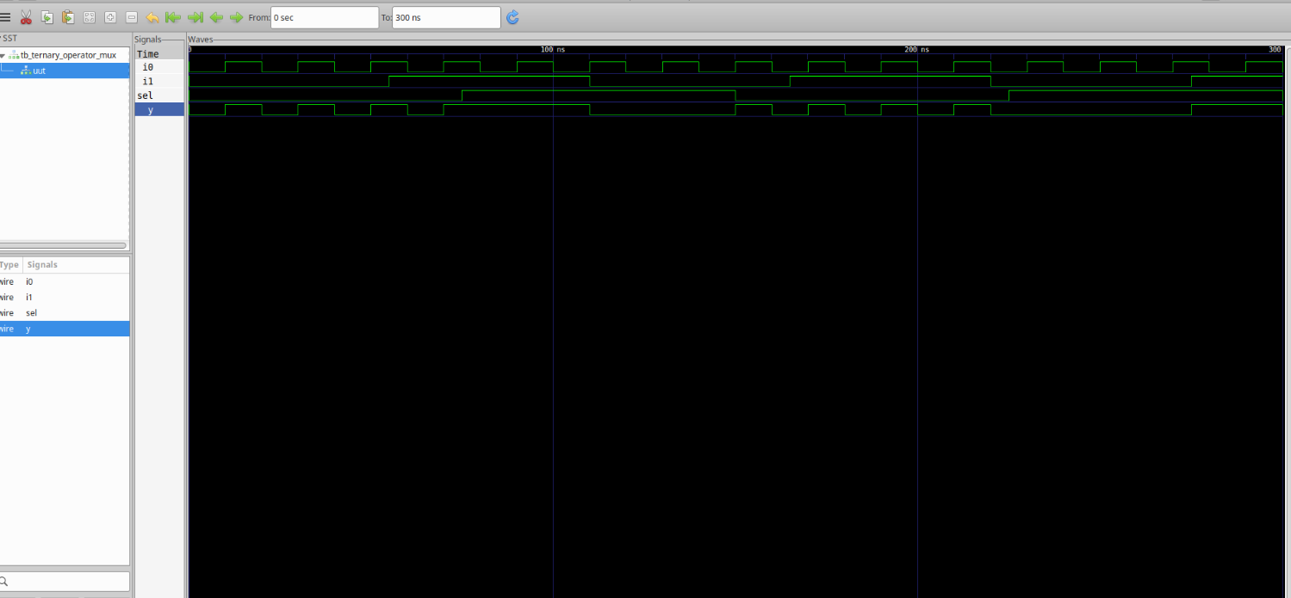

Lab 2: Synthesis of MUX

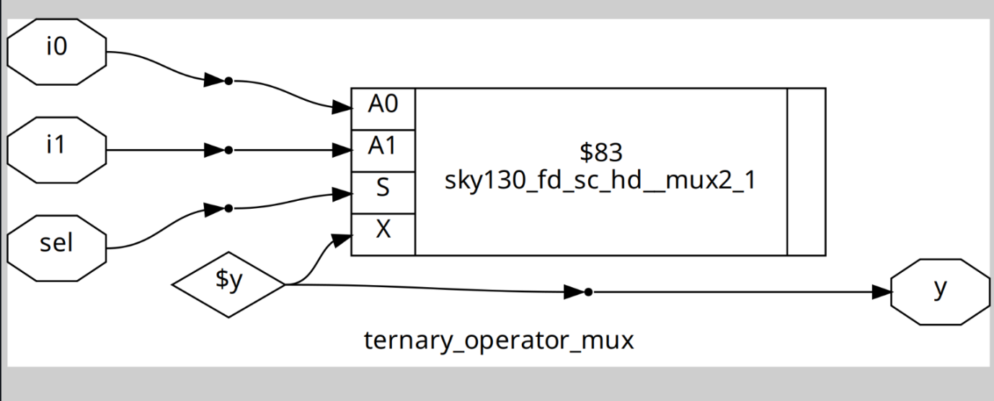

Lab 3: Gate-Level Simulation of MUX
This lab focuses on performing a GLS of the synthesized MUX to verify its functionality. The simulation would use the generated netlist and a testbench.
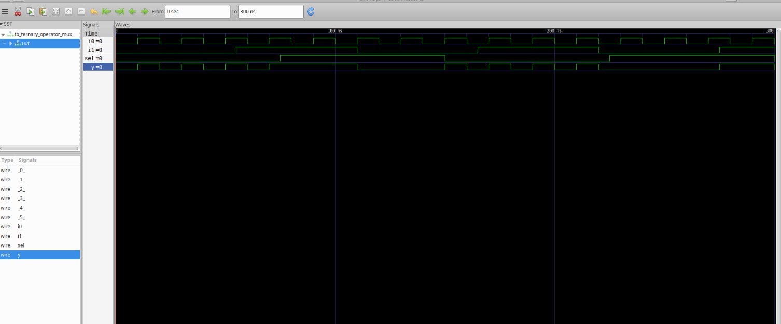

Lab 4: Bad MUX Example (Common Pitfalls)
Verilog Code with Issues:
Verilog
module bad_mux (input i0, input i1, input sel, output reg y);
always @ (sel) begin
if (sel)
y <= i1;
else
y <= i0;
end
endmodule
Issues: This code has two major issues:
- Incomplete Sensitivity List: The always block should be sensitive to i0 and i1 as well. The correct list is always @ (*).
- Incorrect Assignment Type: A combinational circuit should use blocking assignments (=) to ensure immediate updates. Using non-blocking (<=) can lead to simulation mismatches.
Corrected Version:
Verilog
always @ (*) begin
if (sel)
y = i1;
else
y = i0;
end

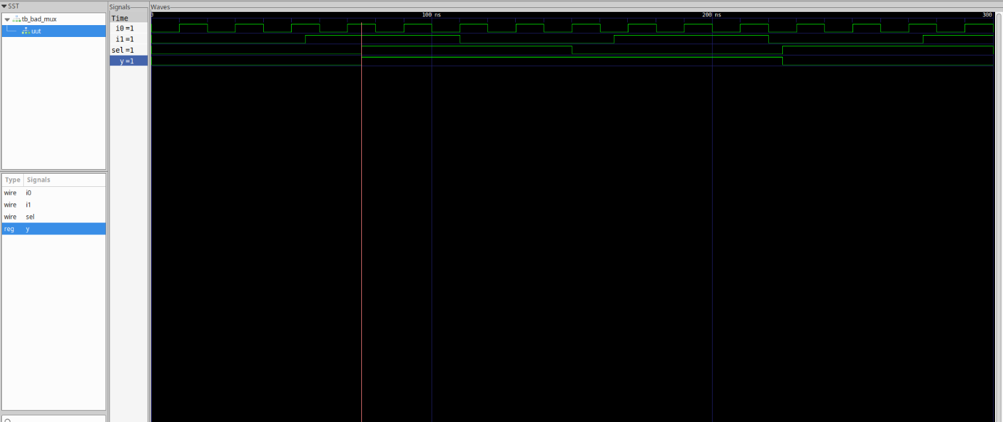

Lab 5: GLS of Bad MUX
This lab demonstrates that simulating the bad_mux module will likely produce simulation warnings or mismatches compared to the synthesized gate-level netlist.
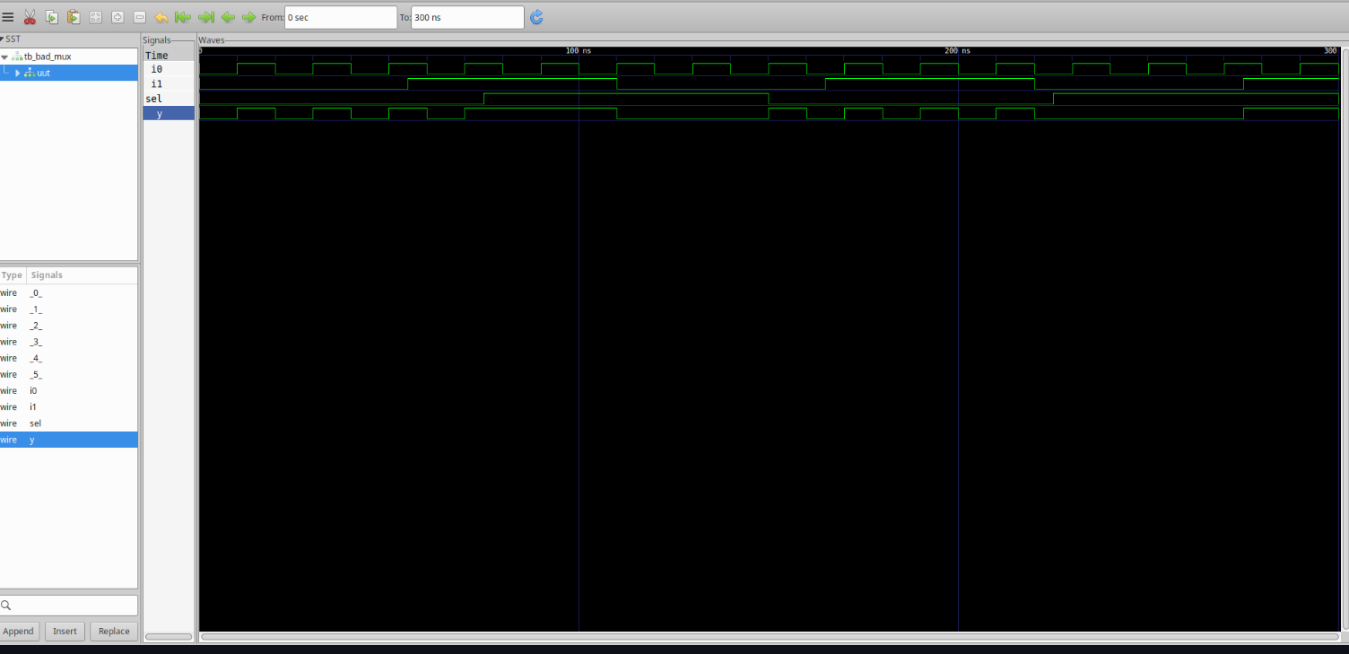

Lab 6: Blocking Assignment Caveat
Verilog Code:
Verilog
module blocking_caveat (input a, input b, input c, output reg d);
reg x;
always @ (*) begin
d = x & c;
x = a | b;
end
endmodule
Problem: The order of assignments is problematic. The statement d = x & c; will use the old value of x before x is updated by the statement x = a | b;. This can lead to a behavioral difference between simulation and synthesis.
Corrected Order:
Verilog
always @ (*) begin
x = a | b;
d = x & c;
end

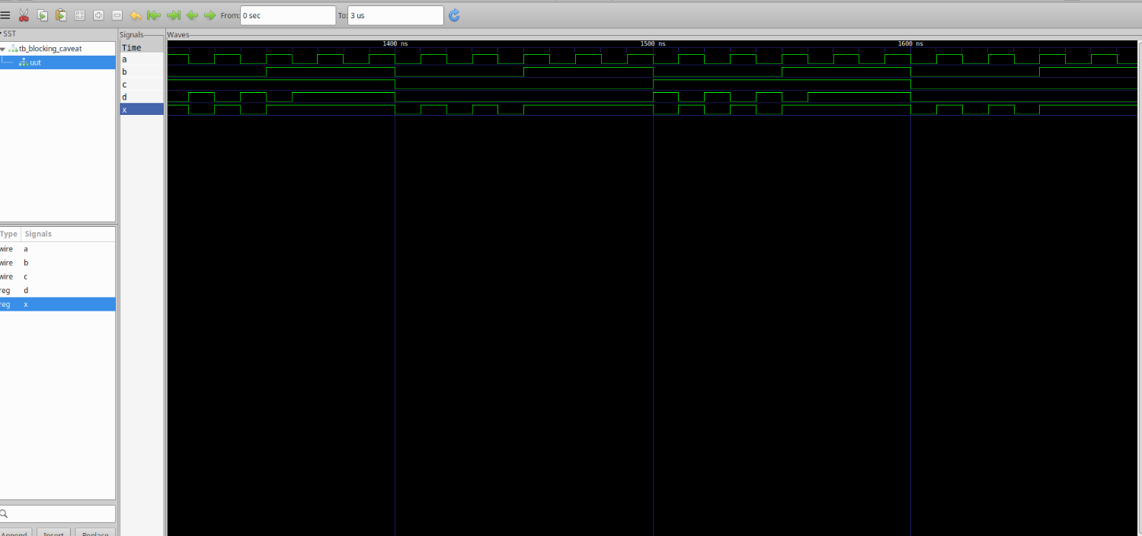

Lab 7: Synthesis of the Corrected Module
This lab involves synthesizing the corrected version of the blocking_caveat module to see the expected and correct hardware implementation.
